RESOLUTION NO.__________

RE: CERTIFICATE OF APPROPRIATENESS UNDER THE
PROVISIONS OF THE ACT OF THE PENNSYLVANIA
LEGISLATURE 1961, JUNE 13, P.L. 282 (53
SECTION 8004) AND BETHLEHEM ORDINANCE NO.
3952 AS AMENDED.

WHEREAS, it is proposed to repaint the exterior and the window trim of the home and repair the brick chimney at 33 E. Wall St.

NOW, THEREFORE, BE IT RESOLVED by the Council of the City of Bethlehem that a Certificate of Appropriateness is hereby granted for the proposal.

Sponsored by: (s)

(s)

ADOPTED BY COUNCIL THIS DAY OF

(s)
President of Council

ATTEST:

(s)
City Clerk

HISTORICAL & ARCHITECTURAL REVIEW BOARD

The applicant proposes to repaint the exterior of the house, the window trim and repair the brick chimney at 33 E. Wall St.
APPLICATION #3:

Pamela Valenza
33 East Wall St.
Bethlehem, PA 18018

OWNER:

__________________________________________________________________

The Board upon motion by Gen Marcon and seconded by Connie Glagola adopted the proposal that City Council issue a Certificate of Appropriateness for the following:

- Repaint exterior of the home Philosophical Grey from Glidden Paints.

- The window trim will be painted Ultra White to match existing trim.

3. Replace the existing chimney with matching materials and reuse existing
chimney cap or replace it.

4. The motion was unanimously approved.

__________________________________________________________________________

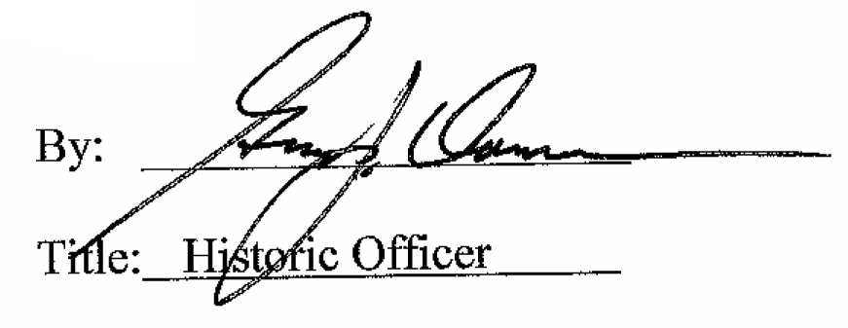

Date of Meeting: Octrober 7, 2015

